Make: Wilkhahn
Model: Graph conference chair
Design: jehs + laub

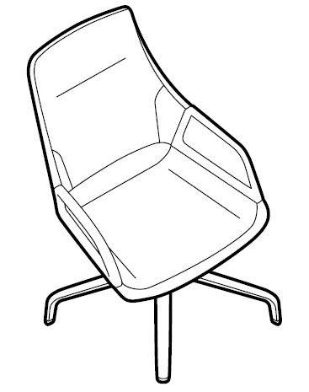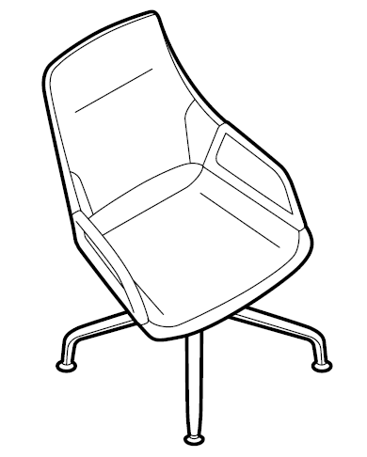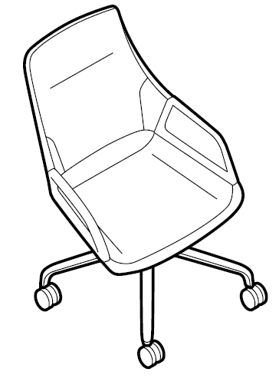

Models:
301/5 medium-height backrest
301/5 medium-height backrest with base glides
301/5 medium-height backrest with castors
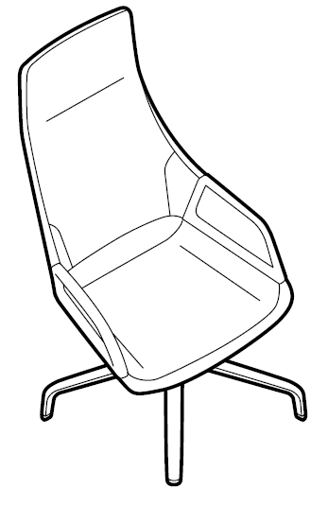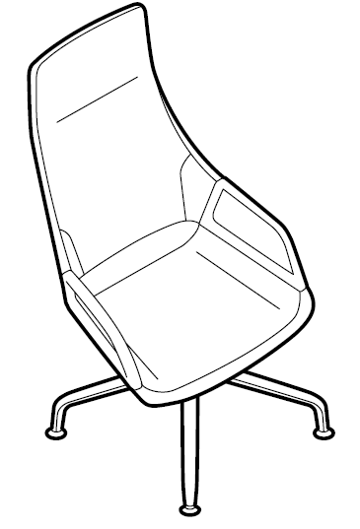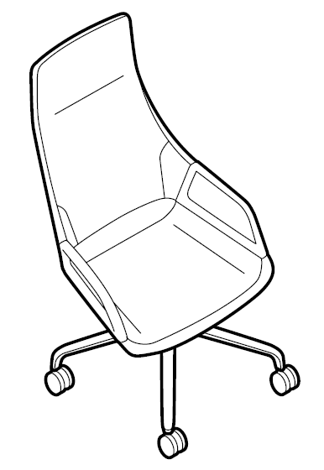
Models:
302/5 high backrest
302/5 medium-height backrest with base glides
302/5 high backrest with castors

Standards / quality labels:
DIN EN 13761
DIN EN 1728
GS standard (safety tested)
ANSI/BIFMA X5.1

Chair dimensions:
Seating height: 43 cm (standard), 44 cm (with base glides), 45 cm (with castors)
Total height (model 301/5): 102 cm (standard), 103 cm (with base glides), 104 cm (with castors)
Total height (model 302/5): 125 cm (standard), 126 cm (with base glides), 127 cm (with castors)
Width: 62 cm
Depth: 64 cm
The seating height is measured under load with DIN testing equipment
Total height, width and depth are the minimum dimensions

Weight:
From 17.1 kg to 17.9 kg (depending on the model and design without packaging)

Description:
Formal, distinctive conference chair
Swivel mounted
Three-dimensional sprung design due to three-point support with a rear spring strut
Superb, sprung comfort which is elastic at the sides
Sophisticated upholstery
Armrests stylishly link the seat and backrest

Frame:
Four-star base 755 mm in diameter made of die-cast aluminium with coating (signal white or black)
Optional: polished star base
Optional: bright, chrome-plated star base
Standard type: black, multi-purpose glides made of plastic for all types of flooring
Optional: matt chrome-plated base glides with a larger area for the chair to stand on for sensitive flooring when polished star bases are chosen
Optional: bright chrome-plated base glides with a larger area for the chair to stand on for sensitive flooring when bright chrome-plated star bases are chosen
Glides: black polyamide for carpets
Glides: soft TPU for hard flooring (e.g. stone)
Glides: felt for wooden flooring (e.g. parquet)
Optional: castors in line with DIN EN 1335 and ANSI BIFMA X 5.1 for conference chairs. Twin wheel swivel castors with load-dependent braking, made of black polyamide in line with DIN EN 12529, with black polyurethane coating for both hard and soft floors
Castors: black plastic shells and a chrome-plated ring when the star base is coated or bright chrome-plated
Castors: black plastic shells with matt chrome-plated rings when the star base is polished
Swivel-mounted column with Y-shaped seat bearer made of die-cast aluminium, surface is the same as the frame
Permanently elastic, rubber/metal connecting elements
Sprung elastic strut made of top-quality spring steel in black
Optional: swivel-return mechanism (only in the standard version – or with base glides)

Seat and back:
Seat and back are connected via the armrests
Seat and backrest frame made of metal
Leaf-sprung frame
Additional cushioning
Fully upholstered with polyurethane
Seat and back cushioning covered in the same material from the Wilkhahn fabric collection
Optional: leather cover from the Wilkhahn leather collection
Optional: fabric or leather cover to customer preferences Wilkhahn will check material’s suitability

Cushioning:
All foam used is CFC-free

Shipment method:
Fully assembled in a box
Packaging sizes:
301/5 medium-height backrest: 710 x 710 x 1070 mm
302/5 high backrest: 710 x 710 x 1300 mm

Armrests:
Armrests connect the seat and the back, finish is the same as the frame
Die-cast aluminium armrests coated (signal white or black)
Optional: polished armrests
Optional: bright chrome-plated armrests

Environmental product information:
Material used approx.: aluminium 35%, steel 40%, plastics 10%, other 15%
Returns, disassembly and recycling:
All Graph conference chair components are suitable for non-destructive disassembly. To guarantee materials are sorted according to type, all components over 150 g in weight are labelled. No agents to protect materials, or organic halogen compounds are used that prevent recycling at a later date. A total of 91 per cent of the chair can be recycled.
For further information visit: http://www.wilkhahn.com/en/about/corporate-responsibility/
LEED (Leadership in Energy & Environmental Design): Information available on request

Certification and awards:
UN Global Compact
ISO 9001
ISO 14001
EMAS
GREENGUARDTM (certified version available on request)
AFRDI Green Tick Product Certification Standard 150, Level A – Platinum
AFRDI Blue Tick Product Certification based on AS/NZS 4438 – Level 6

International design awards:
2012: Mixology Award 2012, Product of the Year
2012: Red Dot design award, 2012 winner
2012: iF product design award 2012
2012: German Design Prize 2012, nomination
2012: Architektur und Office innovation prize
2013: German Design Award 2013
2013: Australian International Design Award + Korean Good Design

Wilkhahn reserves the right to make technical changes to the information provided.
September 2014 version

