Make: Wilkhahn
Model: Timetable Shift flip-top folding table, staggered storage possible
Design: Andreas Störiko

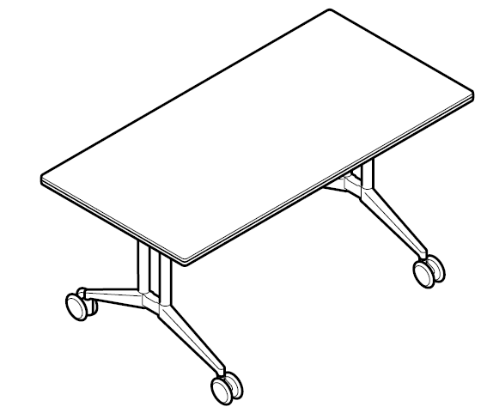
Model:
614 Timetable Shift

Standards:
DIN EN 527
DIN technical report 147
GS standard (safety tested)
ANSI/BIFMA X5.5

Table dimensions:
Height to top edge of table top: 73 cm
Depth x width: 80 x 160 cm, 90 x 150 cm, 90 x 180 cm, 90 x 210 cm, 100 x 160 cm, 100 x 180 cm, 100 x 200 cm, 105 x 210 cm
Barrel-shaped: outside depth / inside depth x width: 80/100 x 180 cm, 80/105 x 210 cm

Weight:
75 x 150 cm size: approx. 40.2 kg (depending on the model and design without packaging)

Description:
Mobile table range with flip-top table tops for versatile use in conference, presentation and meeting rooms, as well as in multi-purpose areas and offices
When flipped up nests into other tables, locking mechanism and staggered storage, staggered storage dimensions: approx. 20 cm required per table (staggered storage dimensions: clearance between the table tops plus one table top thickness)

Frame:
Foot section made of die-cast aluminium, coated (black or silver satin finish)
Optional: polished or bright chrome-plated
Upright made of aluminium profile coated (black or silver satin finish)
Optional: clear anodised (with foot section polished)
Optional: bright chrome-plated (with foot section bright chrome-plated)
Aluminium profile underframe, with integrated cable channel, depending on the foot section coated (silver satin finish or black).
Steel profile table top bearer, coated (black or silver satin finish)
Round steel tube draw rod, depending on foot section black or silver satin finish coating.
Lockable, height-adjustable polyamide swivel castors

Table top:
Particle board class E1
Wood lipping all the way round, optionally bullnose wood or straight lipping, with integral, impact-resilient profile in black elastomer
Edge profiles:
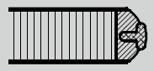
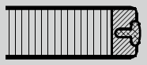

Table top surface:
Table top group 1 – laminate:
Table top thickness 26 mm
Laminate from Wilkhahn colour and surface samples with wood lipping in natural oiled finish

Table top group 2 – veneer:
Table top thickness 26 mm
Variation 1:
Beech, oak and ash veneer from Wilkhahn woodstain colour samples with wooden lipping, as far as possible in the same colour as the veneer
Variation 2:
Maple, walnut or elm veneer, as well as Wilkhahn mocca veneer from the Wilkhahn colour samples with wooden lipping, as far as possible in the same colour as the veneer
Veneer types:
As a standard, the veneers are produced using the slip-match method
Some specific growth features are possible
Surfaces sealed with clear lacquer:
Open-pore: oak, ash, walnut and elm veneer, as well as Wilkhahn Mocca veneer
Closed-pore: maple and beech veneer

Table top group 3: linoleum:
Table top thickness 27 mm
Linoleum from the Wilkhahn colour samples, with laminated beech lipping, natural oiled finish

Optional: A variety of customised options are available on request, shapes, dimensions, surfaces and edges available after feasibility test with Wilkhahn
Special customer designs on request after clarifying technical details with Wilkhahn

Environmental product information:
Materials used in size 70 x 150 cm: wood 53.3%, steel 11.2%, aluminium 17.7%, other metals 12.5%, plastics 5.3%
Returns, disassembly and recycling:
All components in the Timetable series are suitable for non-destructive disassembly.
In order to guarantee materials are sorted according to type, all components over 150 g in weight are labelled. No agents to protect materials, or organic halogen compounds are used that prevent recycling at a later date. A total of 94 per cent of the table can be recycled.
For further information visit: http://www.wilkhahn.com/en/about/corporate-responsibility/

Accessories:
Optional: modesty panels with aluminium frame: coated with a silver satin finish, covered with transparent anthracite fabric, handles made of black polyamide, modesty panels in lengths of 150 cm, 160 cm, 180 cm, 200 cm or 210 cm
Optional: table-table-connectors (Model 613): two rotatable, lockable clips made of black coated sheet steel with 4 star-grip screws
Optional: single table portal Basic: clear anodised aluminium shell with brushed profile, frame placed on the table top, dimensions for single table portal Basic: 300 x 120 mm
Optional: single table portal with brush profile: portal the same colour and material on both sides, flush with the table surface, cut-out section on the table top with genuine wood lipping all around, as far as possible in the same colour as the table top, with hinges that open 180°, single table portal dimensions: 300 x 150 mm
Optional: socket strip (model 708/1, 708/2, 708/4, 708/5) for adding to the underframe, 3 – 4 modules can be selected from various configurations of electricity and/or data, and/or VGA, with the appropriate leads, strain anchor, insertion plates and fastening material, cable clips made of black glass fibre-reinforced polyamide to manage the cable on the table frame’s upright
Optional: integrated techni-station with 3 modules on both sides (model 701/60) or 4 modules (model 701/70), aluminium clear anodised shell, plastic side components colour similar to RAL 9006, black plastic modules, frame attached using a rotary mechanism, ready to connect leads

On request multi-media equipment can be integrated when table top group 3 is chosen

Certification and awards for the Timetable product family (depending on the model):
UN Global Compact
ISO 9001
ISO 14001
EMAS
GREENGUARDTM (undergoing certification)
LEED
The following LEED ratings can be achieved:
LEED CI 5 – 7
LEED NC 4
LEED EB 7

International design awards for the Timetable product family:

2001: Red Dot for top design quality 2001, Design Center NRW
2001: Baden-Württemberg International Design Prize, Design Center Stuttgart
2001: Design Prize Switzerland 2001
2002: iF Product Design Award 2002, Hannover

Wilkhahn reserves the right to make technical changes to the information provided.
September 2014 version

